Project Design Phase
Solution Architecture – FitTrack
Date | 23 September 2026
Team ID | SWTID-2026-4802
Project Name | FitTrack

Solution Architecture:
FitTrack is a fitness and activity tracking solution designed to help users record their fitness activities, manage personal goals, monitor progress, and view useful fitness information in one place.
The solution architecture bridges the gap between the fitness-related needs of users and the technology used to provide the FitTrack system. It defines how the user interface, application services, fitness modules, and data storage work together.
Its goals are to:
• Provide a simple and accessible platform for recording and managing fitness activities.
• Describe the structure, behavior, and major components of FitTrack to project stakeholders.
• Define the main features, development phases, and solution requirements of the FitTrack project.
• Provide specifications for managing user information, fitness activities, progress data, and personalized goals.

FitTrack Solution Architecture Diagram:
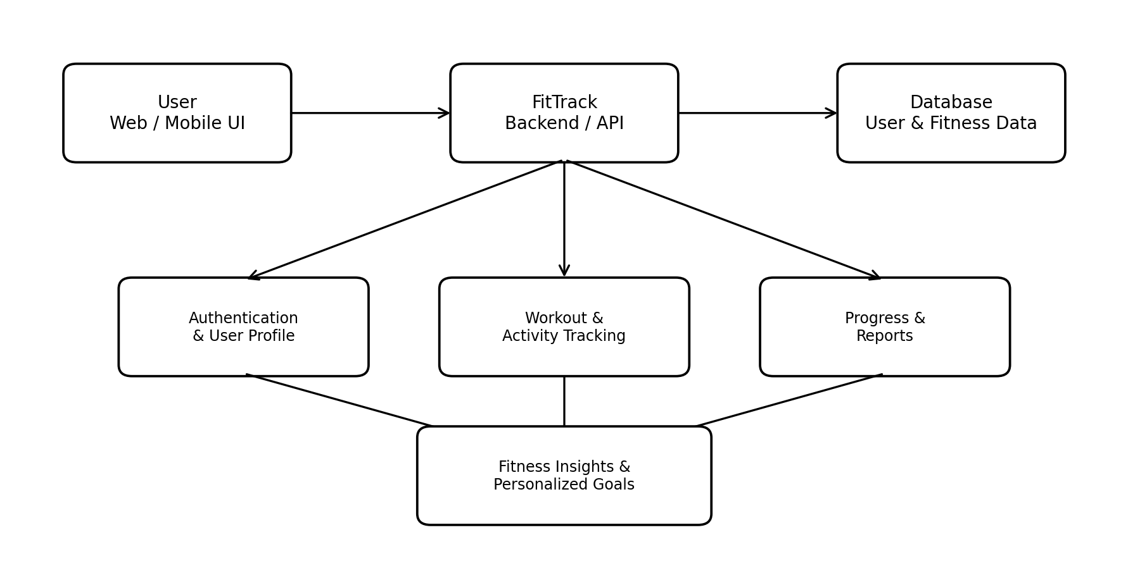
Figure 1: Architecture and data flow of the FitTrack fitness tracking application.
Architecture Components:
User Interface: Allows users to access FitTrack, enter fitness information, view activities, and monitor progress.
Backend / API: Processes requests from the interface and connects the different FitTrack functions with stored data.
Authentication & User Profile: Manages user accounts and personal profile information.
Workout & Activity Tracking: Stores and manages workout and activity records entered by the user.
Progress & Reports: Uses stored activity information to present progress and fitness reports.
Database: Stores user profiles, fitness activities, goals, and progress-related information.
Fitness Insights & Personalized Goals: Uses the available fitness information to help users understand progress and manage their goals.

